Lab 8 ReadMe Doc

By: Jim Nguyen

Lab 02L

11/08/2021

Question 1:

For question 1, the image below shows how I compiled the program on my computer.



After that, it does not require an input at all. My output is shown in the image below.



Then the program promptly ends.

Here are just a written-out versions of the images above.

Compile: g++ part1.cpp -o part1

Run: ./part1

Input(cin): no input at all

Question 2:

For question 2, the image below shows how I compiled the program on my computer.



After that, the program does not require an input at all. My output is shown in the image below.

Then the program promptly ends.

Here are just a written-out versions of the images above.

Compile: g++ part2.cpp -o part2

Run: ./part2

Input(cin): no input at all

Question 3:

For question 3, the image below shows how I compiled the program on my computer.

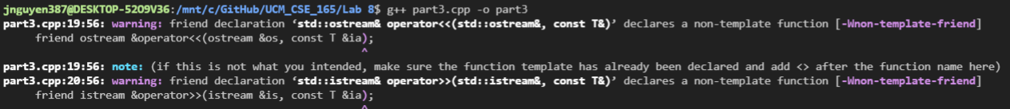

My code produces 2 warnings; however, my TA said that they were okay to have. After that, the program does not require an input at all. An example output is shown in the image below.



Then the program promptly ends.

Here are just a written-out versions of the images above.

Compile: g++ part3.cpp -o part3

Run: ./part3

Input(cin): no input at all